
>>Campaigning for Responsible Investment in Corpus!

OK, so it doesn't sound exciting, but it IS really important - most all bad stuff going on in the world is done with the support of some company, either directly, or by their support for repressive regimes.

The colleges control hundreds of millions, the university around £250 million – but only a fraction of that money is invested with any regard for the potential consequences. Corpus has a £37million endowment invested through Merrill Lynch Investment Managers.

For some examples of corporate irresponsibility that we shouldn’’t want to endorse: BAE Systems helps the Indonesian government repress its indigenous populations; Union Carbide/Dow Chemical killed 16,000 people in India; and Unocal supports the despotic regime in Burma.

And it IS something that WE can do something about. How?
- By EXPOSING what colleges' investment portfolios are doing to PEOPLE in the third world, using students' battels.
- By LOBBYING and NEGOTIATING for change from the university and our college.
- By REFUSING to accept Irresponsible Investment with our money, from institutions we participate in.

But can it WORK?
Yes. Edinburgh, St. Andrews and the University of East Anglia have already seen succesful SRI campaigns. And it has made a difference, for just one example: at least 30,000 Kurds' were saved from homelessness after a campaign for disinvestment from Balfour Beatty helped stop the Ilisu Dam project. (oh, and the fall of Apartheid South Africa…)

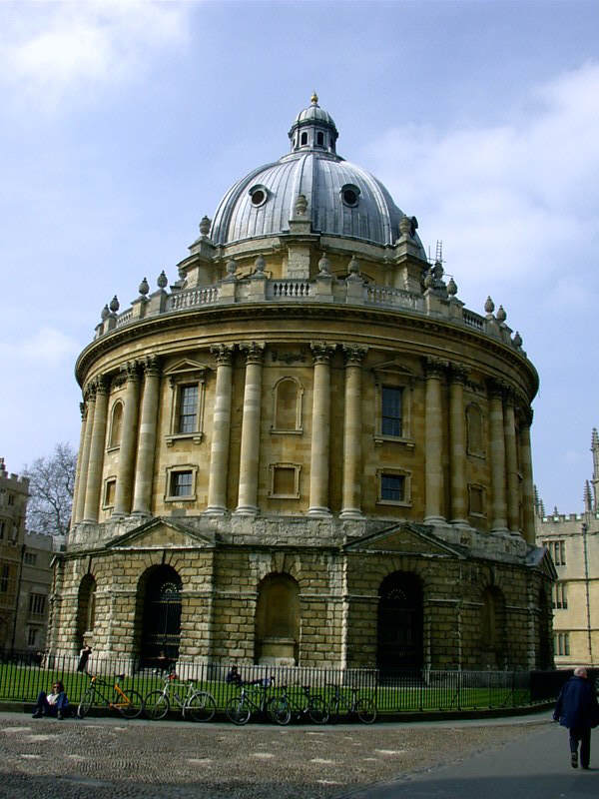

Open meeting for anyone interested in responsible investment in Corpus for discussions, questions and organisation: 8pm Thursday 5th Week.

Think Global, Act Local!

www.SRIoxford.org.uk

